Lab 3

**Problem 1:**

The **n-queens** puzzle is the problem of placing n queens on an n x n chessboard such that no two queens attack each other. Given an integer n, return *all distinct solutions to the* ***n-queens puzzle***. You may return the answer in **any order**.

Each solution contains a distinct board configuration of the n-queens' placement, where 'Q' and '.' both indicate a queen and an empty space, respectively.

**Example 1:**

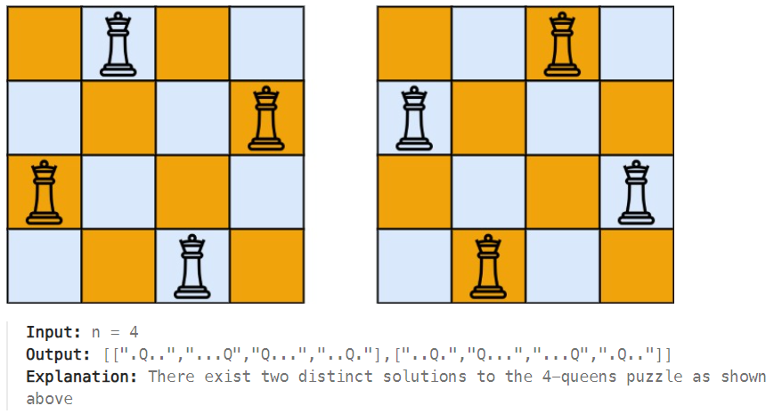

**Problem 2:**

There is a knight on an n x n chessboard. In a valid configuration, the knight starts **at the top-left cell** of the board and visits every cell on the board **exactly once**. You are given an n x n integer matrix grid consisting of distinct integers from the range [0, n * n - 1] where grid[row][col] indicates that the cell (row, col) is the grid[row][col]th cell that the knight visited. The moves are **0-indexed**.

Return true if the grid represents a valid configuration of the knight's movements or false otherwise.

**Note** that a valid knight move consists of moving two squares vertically and one square horizontally, or two squares horizontally and one square vertically. The figure below illustrates all the possible eight moves of a knight from some cell.



**Example 1:**

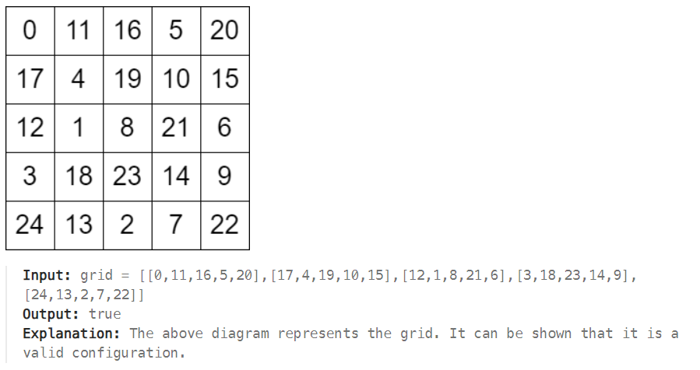

**Example 2:**

